8-channel guideway weighing control module

V2.1

Instruction Manual

Modification date：2022-6-4

**Contents**

1 Summary 2

1.1 Product introduction 2

1.2 Safety tips 2

1.3 Technical parameters and dimensions 4

1.4 I/O 5

2 Operation method 6

2.1 Key and display area definition 6

2.2 Parameter display and setting 6

2.2.1 01-SEt System parameter 7

2.2.2 02--- Spare 8

2.2.3 03-CAL System operation 8

2.2.4 04-INF System information 9

3 Supplementary notes 10

3.1 modbus Communication protocol 10

3.2 Other communications 11

3.2.1 Active sending protocol 11

3.3 Other functions 11

3.4 MODBUS RTU Communication examples 11

# 1 Summary

## 1.1 Product introduction

Thank you for choosing our products. Before using this product, please read this manual carefully to make this product work to the maximum extent.

This product uses 24 bit ∑-△ADC chip,and the analog signal of bridge load cell is converted into digital signal. It have 8 channels.

Suitable for 21-26vdc power supply system.24 V power supply is recommended.

**Product features：**

1. It can prevent RFI / EMI interference and has strong EMC characteristics；
2. 21-26v DC supply；
3. High speed 24 bit ∑-△ADC sampling, with up to 640Hz sampling；
4. Complete communication interface，Standard RS 232 and 485.Optional CAN, Ethernet,etc。

## 1.2 Safety tips



1. The instrument has anti-interference design. Be sure to ground the instrument reliably and separate it from the AC power supply ground wire;
2. Do not use in flammable gas environment;
3. Avoid direct sunlight;
4. The communication station is recommended to use the same 24 V power supply as the module, otherwise the communication connection needs to be transmitted through the isolation module [for example, the PLC is AC220 V, and the communication isolation module needs to be added between PLC and this module].

## 1.3 Technical parameters and dimensions

|  |  |
| --- | --- |
| **Measurement signal** | 8 channel with -20mV~20mV，Each can drive 4 load cells with 350 ohm |
| **Sampling frequency** | 10Hz,40Hz,640Hz |
| **Accuracy** | III level |
| **Resolution** | 1/500000 |
| **Communication** | rs 232,rs 485.Optional with Ethernet or CAN |
| **Nonlinearity** | 0.005%FS |
| **Power** | 21-26V DC.Sensor voltage 5V. |
| **Weight** | About 0.1kg |
| **Dimensions** | 145*90*40 |
| **Power waste** | < 5W |
| **Temperature** | -20~+65℃ |

## 1.4 I/O

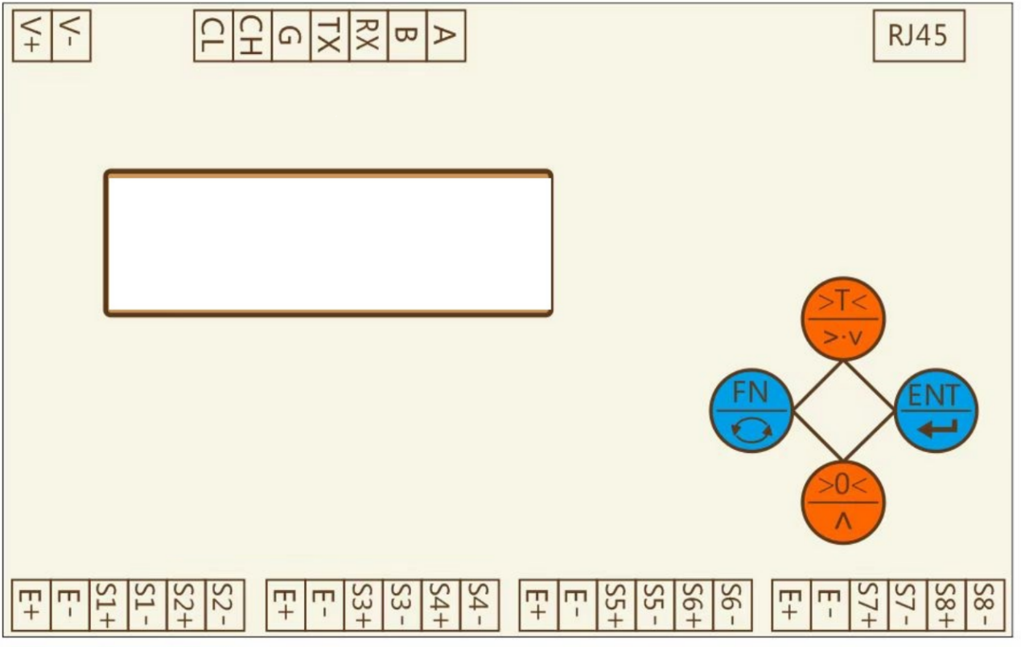

Explain

1：V + andV - to connect the DC power, and 24 V DC is recommended；

2：E+、E-、are loadcell’s power,S1+、S1-、 S2+、S2-......S8+、S8-、are loadcell’s signal；

3：A / B is 485 interface；G、TX、RX is 232 interface;CL and CH for CAN interface；RJ45 is an Ethernet interface.

4：Loadcell’s shielded reliably grounded；

# 2 Operation method

## 2.1 Key and display area definition

The main screen shows the weight value. 8-channel cycle switching display. The value after CH01 is the weight of channel 1, and the value after CH02 is the weight of channel 2，and so on.

For 4 keys：1575808054(1) 1575808085(1) 1575808103(1) 1575808125(1)

1575808054(1):Enter the menu / return to the previous level. Long press on the main screen, enter the password to unlock.

1575808085(1): The menu screen is changing menu options; the parameter screen is modifying, and the cursor is moving;

1575808103(1)：The menu screen is to change the menu options; the parameter screen is to modify and increase the value;

1575808125(1)：Confirm this operation.

## 2.2 Parameter display and setting

Before inputting parameters, press 1575808054(1) in the main screen，input the password 123；

Press1575808054(1)in the main screen to enter parameter setting screen，01-set is displayed(System parameter)，Press1575808085(1)1575808103(1)，can switch the display 02—--(Spare)、03-CAL(System operation)、04-INF(System information).Press1575808125(1)can enter the corresponding parameter table.then，press1575808085(1)1575808103(1)can switch display other parameters.Press1575808125(1)，enter parameter modification status or next level display.Press1575808054(1)more than 3 seconds，You can directly exit to the weight display interface.

### 2.2.1 01-SEt System parameter

Press1575808054(1)in the main screen,01-set is displayed,press1575808125(1)，Enter the system parameter display,The parameters included are shown in the following table：

|  |  |  |  |  |
| --- | --- | --- | --- | --- |
| Display | Definition | Default(Range) | Describe | REG |
| 01-000 | decimal point | 2(0-4) |  | 1001 |
| 01-001 | Zero 1 | 0(0-999999) | Saved zero AD values. | 1003 |
| 01-002 | Zero 2 | 1005 |
| 01-003 | Zero 3 | 1007 |
| 01-004 | Zero 4 | 1009 |
| 01-005 | Zero 5 | 1011 |
| 01-006 | Zero 6 | 1013 |
| 01-007 | Zero 7 | 1015 |
| 01-008 | Zero 8 | 1017 |
| 01-009 | Coefficient 1 | 1000(1-999999) | Coefficient formed at full calibration. | 1019 |
| 01-010 | Coefficient 2 | 1021 |
| 01-011 | Coefficient 3 | 1023 |
| 01-012 | Coefficient 4 | 1025 |
| 01-013 | Coefficient 5 | 1027 |
| 01-014 | Coefficient 6 | 1029 |
| 01-015 | Coefficient 7 | 1031 |
| 01-016 | Coefficient 8 | 1033 |
| 01-017 | Filter | 16(0-19) | The larger the value is, the better the filtering effect is, but the weight display lags behind. | 1035 |
| 01-018 | Division | 0(0-5) | 0:1 1:2 2:5 3:10 4:20 5:50。 | 1037 |
| 01-019 | Dyn.Range | 0.01(0.00-99.99) | When this value is greater than 0, it starts to judge whether it is stable. | 1039 |
| 01-020 | Dyn.Time | 0.30(0.00-9.99) | During this time, if the weight change is within the stable range, it will be stable. | 1041 |
| 01-021 | Creep Range | 0.00(0.00-99.99) | When this value is greater than 0, creep correction is carried out. | 1043 |
| 01-022 | Creep Time | 10.00(0.00-99.99) | In this time, the weight change is in the Creep Range and is stable, so the creep correction is carried out. | 1045 |
| 01-023 | Zero Range | 0.00(0.00-99.99) | When the value is greater than 0, the auto zero operation is performed. | 1047 |
| 01-024 | Zero Time | 1.00(0.00-9.99) | During this time, if the weight is within the range and is stable all the time, it will be automatically set to zero. Continuous stability is set to zero only once. | 1049 |
| 01-025 | Address | 1(0-128) |  | 1051 |
| 01-026 | Baud of 232 | 1(0-4) | 0:9600 1:19200 2:38400 3:57600 4:115200 | 1061 |
| 01-027 | Check of 232 | 0(0-2) | 0:None 1:Even 2:Odd | 1063 |
| 01-028 | Function of 232 | 0(0-9) | 0:RTU 1:Send Other：Unused | 1065 |
| 01-029 | Order of 232 | 0(0-3) | 0:1234 1:2143 2:3412 34321 | 1067 |
| 01-030 | Baud of 485 | 1(0-4) | 0:9600 1:19200 2:38400 3:57600 3:115200 | 1069 |
| 01-031 | Check of 485 | 0(0-2) | 0:None 1:Even 2:Odd | 1071 |
| 01-032 | Function of 485 | 0(0-9) | 0:RTU 1:Send 2：TCP(Valid with Ethernet module) Other：Unused | 1073 |
| 01-033 | Order of 485 | 0(0-3) | 0:1234 1:2143 2:3412 34321 | 1075 |
| 01-041 | Sampling Frequency | 1(0-2) | 0:10Hz 1:40Hz 2:640Hz | 1083 |
| others |  |  | Unused |  |

### 2.2.2 02--- Spare

### 2.2.3 03-CAL System operation

Press1575808054(1)in the main screen，01-set is displayed，press1575808085(1)1575808103(1)switch display to 03-CAL，Press1575808125(1)enter the function operation of the module，For example, zero calibration, full calibration, etc. The operations included are shown in the following table：

|  |  |  |
| --- | --- | --- |
| Display | Functions | Describe |
| 03-000 | Zero 1 | Zero calibration for 1-8channel |
| 03-001 | Zero 2 |
| 03-002 | Zero 2 |
| 03-003 | Zero 4 |
| 03-004 | Zero 5 |
| 03-005 | Zero 6 |
| 03-006 | Zero 7 |
| 03-007 | Zero 8 |
| 03-008 | Full 1 | full calibration for 1-8 channel |
| 03-009 | Full 2 |
| 03-010 | Full 3 |
| 03-011 | Full 4 |
| 03-012 | Full 5 |
| 03-013 | Full 6 |
| 03-014 | Full 7 |
| 03-015 | Full 8 |

**Zero：**When 03-000 is displayed，press1575808125(1)，display AD values，Press1575808125(1)again，Show 3 seconds countdown, the end of timing, automatically save zero, and return to 03-000

**Full：**When 03-004 is displayed，Put the weight on the weighing table first，then press1575808125(1)，Input the weight，press1575808125(1)，the weight will display.if the AD have some error，it will display Err.Then press1575808125(1)，Show 3 seconds countdown, the end of timing, automatically save zero, and return to 03-008.

### 2.2.4 04-INF System information

Press1575808054(1)in the main screen，01-set is displayed，press1575808085(1)1575808103(1)switch display to 04-INF，Press1575808125(1)enter the function operation of the module：

|  |  |  |
| --- | --- | --- |
| Display | Functions | Describe |
| 04-000 | Version | Query version, instrument error and other information |
| 04-001 | Password | Set password, restore default, etc |
| 04-002 | Test | Factory test and related factory operation |

**Version：**For manufacturer's use only

**Password：**04-001 is displayed，press1575808125(1)，press1575808085(1)1575808103(1)can switch display “01-PASS”,“02-dEF”,“03-FAC”.

“01-PASS” is displayed，press1575808125(1)，can change the password.Input the old password first，then input the new password.

“02-dEF”is displayed，press1575808125(1)，then select Yes，Press1575808125(1)again，will default。

“03-FAC”is displayed，For manufacturer's use only.

**Test：**04-002 is displayed，press1575808125(1)，press1575808085(1)1575808103(1)can switch display “CH01”、“CH02”......“CH08”.press1575808125(1)to view the corresponding AD value.

# 3 Supplementary notes

## 3.1 modbus Communication protocol

The default set is 19200,1 start bit，8 data bit，1 stop bit，none.All data is 32 bit.

|  |  |  |  |
| --- | --- | --- | --- |
| Name | Default(Range) | Describe | Address |
| Weight 1 |  | Write 0:Zero；Write other values,means input the weight on scale. If the weight is 2 decimal points and the weight is 10.00, write 1000. | 1 |
| Weight 2 |  | 3 |
| Weight 3 |  | 5 |
| Weight 4 |  | 7 |
| Weight 5 |  | 9 |
| Weight 6 |  | 11 |
| Weight 7 |  | 13 |
| Weight 8 |  | 15 |
| Other state 1 |  | AD fault。2 bit，overflow,Maybe the sensor is broken or the signal wire is broken；3 bit，Module error. | 17 |
| Other state 2 |  | 19 |
| Other state 3 |  | 21 |
| Other state 4 |  | 23 |
| Other state 5 |  | 29 |
| Other state 6 |  | 31 |
| Other state 7 |  | 33 |
| Other state 8 |  | 35 |
| AD 1 |  | Read | 37 |
| AD 2 |  | 39 |
| AD 3 |  | 41 |
| AD 4 |  | 43 |
| AD 5 |  | 45 |
| AD 6 |  | 47 |
| AD 7 |  | 49 |
| AD 8 |  | 51 |

## 3.2 Other communications

### 3.2.1 Active sending protocol

|  |  |  |  |  |  |
| --- | --- | --- | --- | --- | --- |
| START | [+/-] | DATA | DEC[0-3] | XOR | END |
| 0x02 | 0x2B/0X2D | 6 chars | 0x30-0x33 | 2 chars | 0xFF |

1:The data is transmitted in ASCII code. For example, if 1234 is displayed, hexadecimal 30 31 32 33 34 will be passed.

2:The XOR operation is performed on all data[not contain a start character] before the XOR check bit，and can get a byte of data，Then the byte is converted into two ASCII codes. For example, the computed check is 0x4a, and the corresponding hexadecimal ASCII is 34 41.

3:4-channel data, symbols and data, a total of four frames, each frame contains seven bytes of data, which are symbol + data;

## 3.3 Other functions

If you need the function of CAN, please contact the manufacturer in advance. The configuration and testing tools of Ethernet can be obtained from the manufacturer.

## 3.4 MODBUS RTU Communication examples

The address of the company adopts Siemens system address description rules, and the actual instruction is sent. The instruction is hexadecimal, and the address needs to be reduced by 1.

**Master to slave read data operation**

The host reads 32 bits of register 1，the order is：

    01             03             00 00           00 02          C4 0B

  Slave    Function number   Data address   Data number    CRC check

Then the MCU receives the data, calculates CRC according to the data, and judges whether the data is correct, if the data is correct，The back data order like this：

    01         03             04             00 01 E2 40          E2 A3

Slave    Function number Data number    data     CRC Check

The four hex data are converted to decimal , which is 123456.

**Master to slave write data operation**

The host write 32 bits of register 1，the order is

Write the weight 123456，the order is：

    01          10        00 00      00 02       04   00 01 E2 40  EB 3F

 Slave    Function No.  Data Addr.  Reg.No.  Char No.   Data   CRC Check

Do Zero，the order is：

    01          10       00 00         00 02       04   00 00 00 00  F3 AF

 Back：

01          10        00 00         00 02         41 C8

Slave    Function No.  Data Addr.  Reg.No.     CRC Check

**Modbus RTU CRC check code calculation method**

//modbus CRC16

publicvoid CRC16Calc(byte[] dataBuff, int dataLen)

{

int CRCResult = 0xFFFF;

if (dataLen < 2)

{

   return;

}

for (int i = 0; i < (dataLen - 2); i++)

{

    CRCResult = CRCResult ^ dataBuff[i];

for (int j = 0; j < 8; j++)

{

if ((CRCResult & 1) == 1)

CRCResult = (CRCResult >> 1) ^ 0xA001;

else CRCResult >>= 1;

}

}

dataBuff[dataLen - 1] =Convert.ToByte(CRCResult >> 8);

dataBuff[dataLen - 2] =Convert.ToByte(CRCResult & 0xff);

}